SYNOPSIS REPORT

Title of the Project: Calculate Buddy

Submitted by:
Name: Karan Nair
Branch: AIML
Section: A

Submitted To:
Prop.Manan Rasool
Academic Year:- 2025-2026

Table of Contents

Sr. No. | CONTENT
1 | Introduction
2 | Objective
3 | Methodology
4 | Features Explained
5 | System Flowchart
6 | Future Scope
7 | Conclusion

1. Introduction
This Python mini project is a Simple Calculator that I created using Python. The main idea of this project is to calculate and perform mathematical operators through a program.
The project lets users calculate:
- Area of 2D shapes like square, rectangle, circle, triangle, ellipse, parallelogram
- Area of 3D shapes like cube, cuboid, sphere, cylinder, cone, hemisphere.
- Volume of 3D shapes like cube, cuboid, sphere, cylinder, cone, hemisphere.
- Perimeter of shapes
- Basic arithmetic (add, subtract, multiply, divide)
- Powers (square, cube, square root)
- Loan Calculator (EMI)
I have used Pythons basic concepts like loops, variables, conditional statements, and the math module to simplify calculations. Overall, this project can be useful for student because he can find area, volume and etc by just inputing values.

2. Objective
The main objective of this mini project is to create a Calculator using Python that performs various mathematical operations. I faced this problem in my schooling that’s why I made this project by which it can be helpful for student . So I added features like calculating area, volume, perimeter by just inputing the values. Through this project, my goal was to apply Python concepts in a practical way and learn how to build a little advance calculator on my own.

3. Methodology
3.1 Tools Used
- Python 3.13.7
- VS code
- Libraries: Math

4. Features Explained.
For this project, I followed a step-by-step approach to build the Calculator. First I planned what features a Calculator should have, like area calculator, volume calculator, perimeter calculator, power calculations, EMI calculator.
4.2.1 Calculator Menu
Shows a menu so the user can choose which tool to use (Area 2D, Area 3D, Volume, Perimeter, Power Menu, Loan Calculator, Basic Calci, Exit).
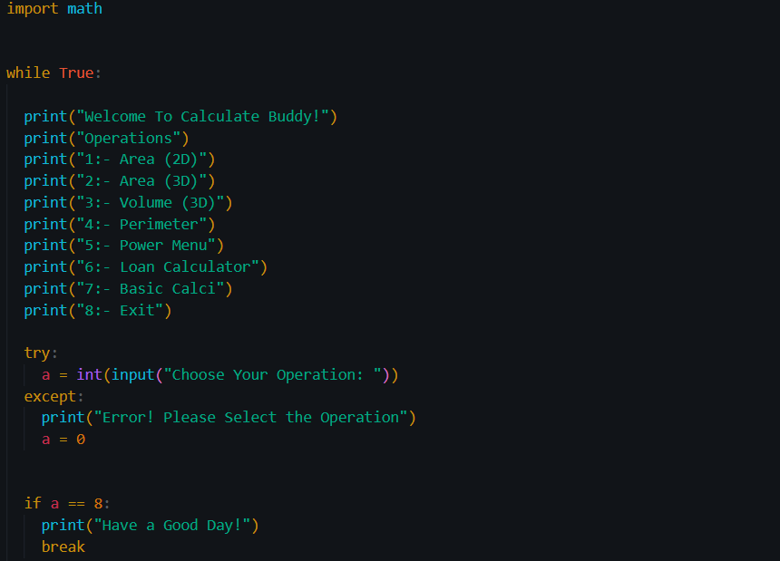

4.2.2 Area (2D shapes)
For calculating Area of square, rectangle, circle, triangle, ellipse and parallelogram. User can put values for there selected shape and by the in built formula the area will printed.
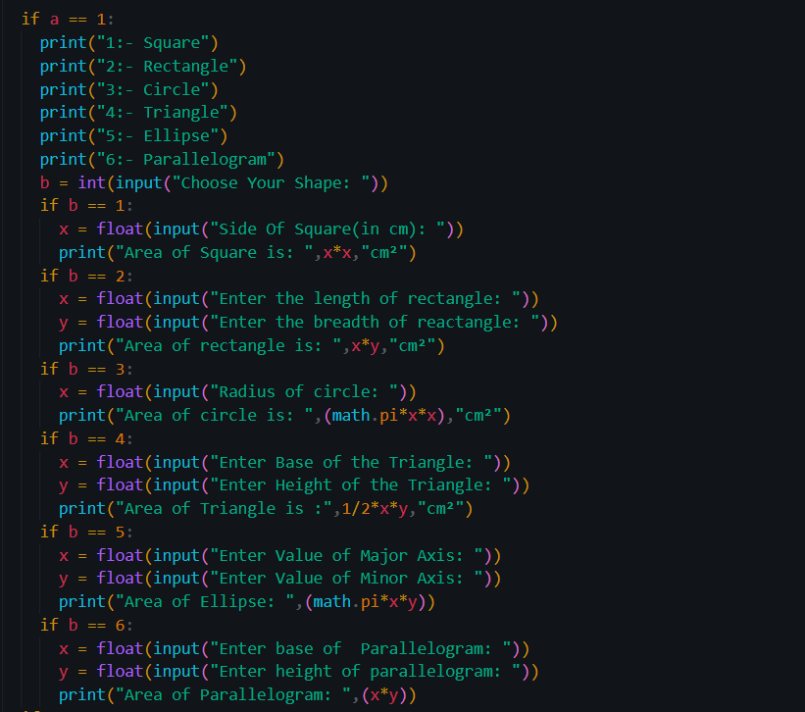

4.2.3 Area (3D shapes)
Calculates surface area for cube, cuboid, sphere, cylinder, cone, hemisphere. When user inputs the requires values it prints the surface area of selected shape.
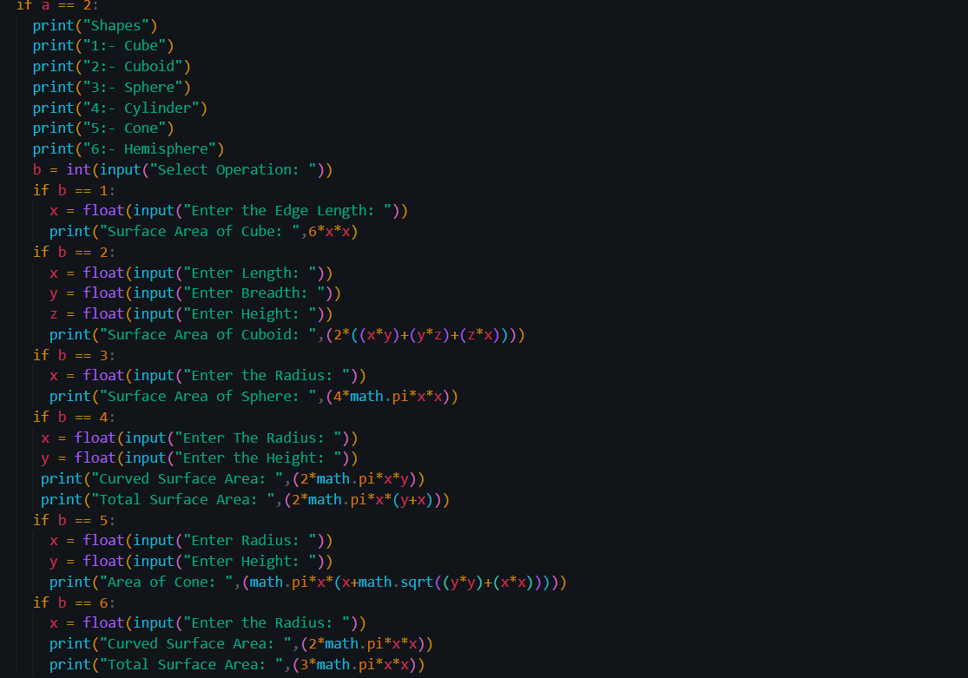

4.2.4 Volume (3d shapes)
Calculates volume for cube, cuboid, sphere, cyinder, cone, hemisphere. User can input the required value can volume for the selected shape is printed.
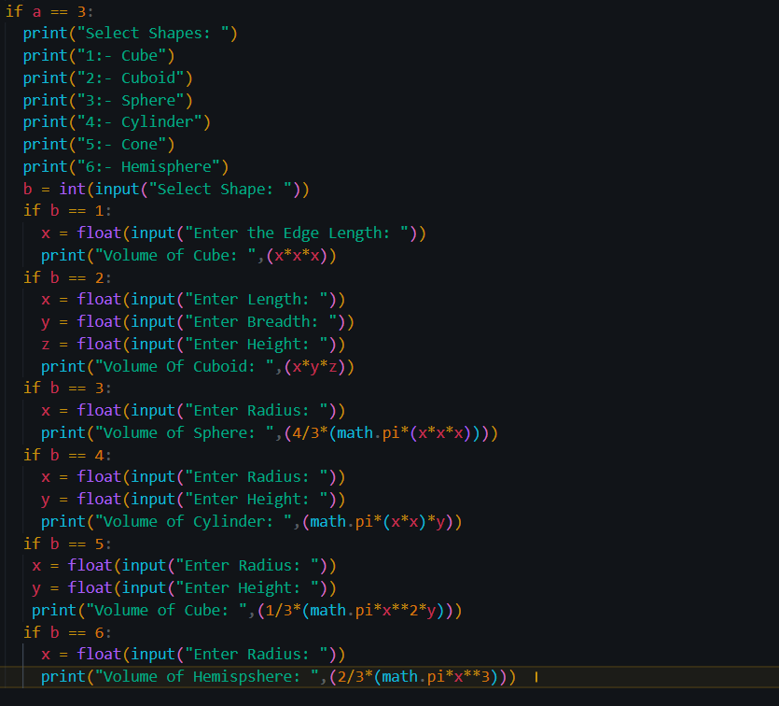
4.2.5 Perimeter
Calculates perimeter for square, rectangle, circle, triangle. When user inputs the value the perimeter for the selected shape prints.
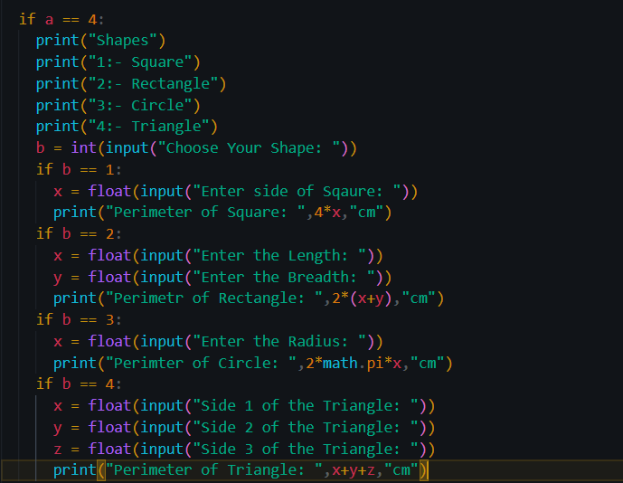
4.2.6 Power Menu
Prints square, sube, and square root for a number.
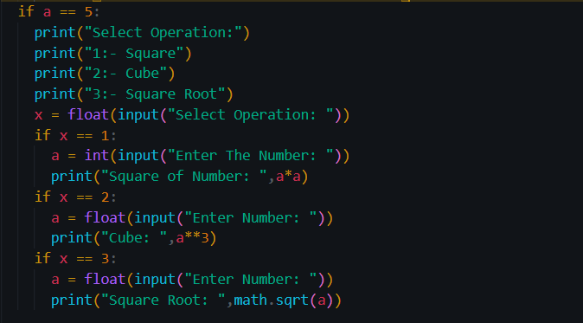
4.2.7 Loan (EMI) Calculator
Calculates monthly EMI from loan amount, monthly interest rate and number of months.
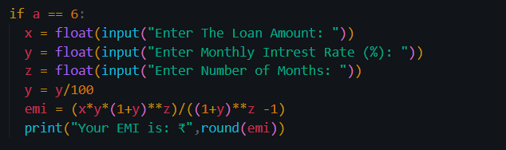
4.2.8 Basic Calculator
Performs addition, subtraction, multiplication, division.
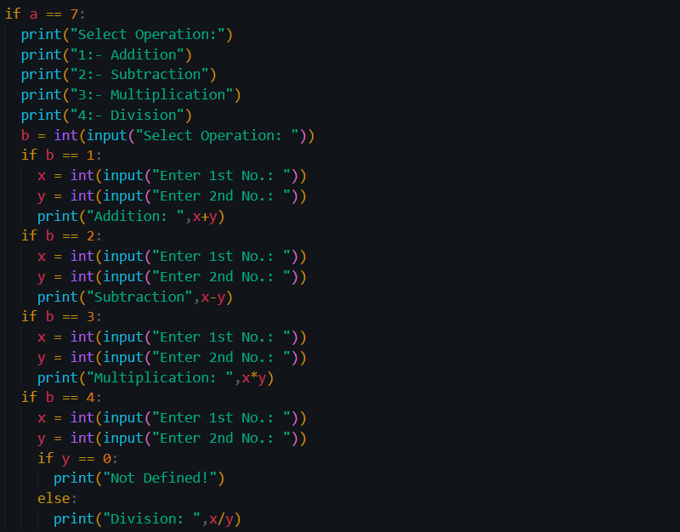

5. System Flow Chart
Start
Select Operation
Read Shape
Request Input
Compute Area
Print Result
6. Future Scope
1. Less Repetition in code
2. Induce GUI in the project
3. Adding Missing Shapes and add more calculation sections
4. Add income tax calculator to Calculate Buddy
5. Add Unit Conversion
6. Turn this project into a website with proper graphics
7. Conclusion
Working on this project helped me understand how this mathematical concepts can be calculate with Python. I learned how to make to take input, use loop and apply conditional statement , nested if-else. Adding Area and Volume calculator can help school students to find area and volume just by inputing the required values. Overall, this project gave me clear idea of how to calculate using python and improve logic building skills. This was a good learning experience , and it also opened up many ideas for future improvements.

